1. Create Java classes having suitable attributes for Library management system.Use OOPs concepts in your design.Also try to use interfaces and abstract classes.
Answer 1 :
Interface -->
package Questions.question1;
public interface LibraryPro {
int lib_seat_cap=500;
void issueBook();
void returnBook();
}
Abstract Class -->
package Questions.question1;
abstract class Library {
String lib_name;
String lib_address;
public Library(){
lib_name="Global Library";
lib_address="Sector 127 Noida";
}
public abstract void getLibraryInfo();
}
Main Class-->
package Questions.question1;
import java.util.Calendar;
import java.util.Date;
public class Lib extends Library implements LibraryPro {
String member_name;
int member_contact;
String member_book;
Date issue_date;
Date return_date;
public Lib(String mem_name,int mem_con,String mem_book){
this.member_name=mem_name;
this.member_contact=mem_con;
this.member_book=mem_book;
}
@Override
public void getLibraryInfo() {
System.out.println("Library name is : "+lib_name);
System.out.println("Library Address is : "+lib_address);
System.out.println("Library Seat Capacity : "+lib_seat_cap);
}
@Override
public void issueBook() {
Date d=new Date();
issue_date=d;
Calendar calendar=Calendar.getInstance();
calendar.add(Calendar.DATE,7);
return_date=calendar.getTime();
System.out.println("succesfully Book issued to "+member_name+" on date "+issue_date.toString()+" and return on "+return_date);
}
@Override
public void returnBook() {
if(issue_date==null && return_date==null){
System.out.println("No book has been issued");
}else{
issue_date=null;
return_date=null;
System.out.println("book has been returned successfully");
}
}
public void getMemberDetails(){
if(issue_date==null && return_date==null){
System.out.println("Member Name : "+member_name);
System.out.println("Member Contact : "+member_contact);
System.out.println("Member book : "+member_book);
System.out.println("Now No Book has been issued to the "+member_name);
}else{
System.out.println("Member Name : "+member_name);
System.out.println("Member Contact : "+member_contact);
System.out.println("Member book : "+member_book);
System.out.println("Issue Date : "+issue_date);
System.out.println("return Date : "+return_date);
}
}
}
class Main{
public static void main(String[] args) {
Lib lib=new Lib("Shivam",84545414,"Daa");
Lib lib1=new Lib("satyam",5545541,"Physics");
lib.getLibraryInfo();
lib.issueBook();
lib.returnBook();
lib.getMemberDetails();
lib1.issueBook();
lib1.returnBook();
lib1.getMemberDetails();
}
}
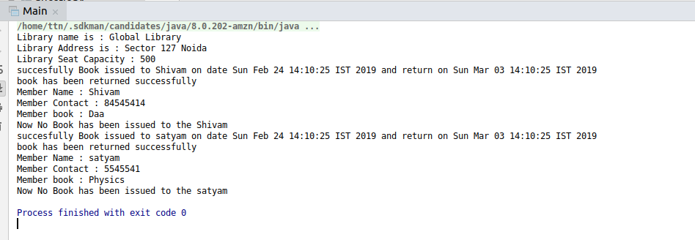

2. WAP to sorting string without using string Methods?.
package Questions.question2;
public class StringSort {
public static void main(String[] args) {
String str = "shivam";
char[] chars = str.toCharArray();
char temp;
for (int i = 0; i < chars.length; i++) {
for (int j = 0; j < chars.length-1; j++) {
if(chars[j]>chars[j+1]){
temp=chars[j];
chars[j]=chars[j+1];
chars[j+1]=temp;
}
}
}
for(int k=0;k<chars.length;k++){
System.out.println(chars[k]);
}
}
}
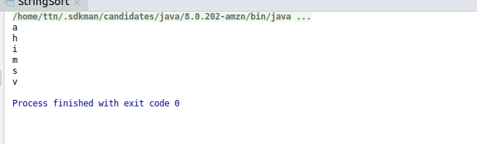

3. WAP to produce NoClassDefFoundError and ClassNotFoundException exception.
package Questions.question3;
public class ClassNotFoundExceptionExample {
private static final String Class_to_load="main.java.Utils";
public static void main(String[] args) {
try{
Class loadedClass=Class.forName(Class_to_load);
System.out.println("Class" + loadedClass +"founded successfully");
}catch(ClassNotFoundException ex){
System.out.println(ex);
}
}
}
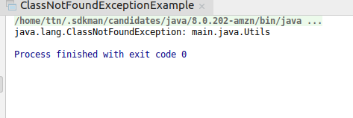

package Questions.question3;
public class ThrowableExample {
public String name="shivam";
public void changeName(){
System.out.println("hello world");
}
}
class Main{
public static void main(String[] args) {
ThrowableExample throwableExample=new ThrowableExample();
throwableExample.changeName();
}
}
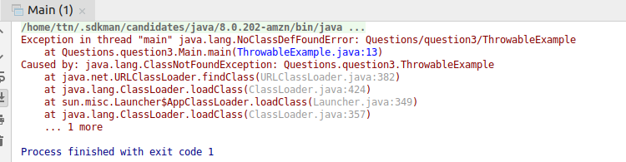

4. WAP to create singleton class.
package Questions.question4;
class SingletonExample {
private static SingletonExample single_instance = null;
public String x;
private SingletonExample() {
x = "Hello This is Singleton String";
}
public static SingletonExample getInstance() {
if (single_instance == null) {
single_instance = new SingletonExample();
}
return single_instance;
}
}
class Main{
public static void main(String[] args) {
SingletonExample singletonExample=SingletonExample.getInstance();
SingletonExample singletonExample1=SingletonExample.getInstance();
SingletonExample singletonExample2=SingletonExample.getInstance();
singletonExample.x=(singletonExample.x).toUpperCase();
System.out.println(singletonExample.x);
System.out.println(singletonExample1.x);
System.out.println(singletonExample2.x);
System.out.println("\n");
singletonExample1.x=(singletonExample1.x).toLowerCase();
System.out.println(singletonExample.x);
System.out.println(singletonExample1.x);
System.out.println(singletonExample2.x);
}
}
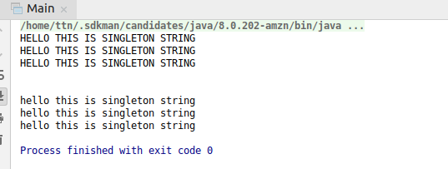

5. WAP to show object cloning in java using cloneable and copy constructor both.
package Questions.question5;
public class StudentInfo implements Cloneable {
private String name;
private int age;
public StudentInfo(String n,int a){
this.name=n;
this.age=a;
}
public Object clone() throws CloneNotSupportedException {
return super.clone();
}
public static void main(String[] args) {
try {
StudentInfo studentInfo=new StudentInfo("Shivam",19);
StudentInfo studentInfo1=(StudentInfo)studentInfo.clone();
System.out.println(studentInfo.name +" And Age is "+studentInfo.age);
System.out.println(studentInfo1.name+" And Age is "+studentInfo1.age);
} catch (CloneNotSupportedException e) {
e.printStackTrace();
}
}
}
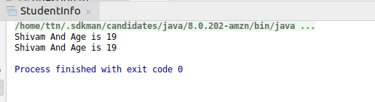

6. WAP showing try, multi-catch and finally blocks.
package Questions.question6;
public class TryCatchExample {
public static void main(String[] args) {
try {
int a = 10 / 0;
String[] str=new String[3];
System.out.println(a);
System.out.println(str[4]);
} catch (ArithmeticException ae) {
System.out.println("this is Arithmetic Exception : "+ae);
} catch(ArrayIndexOutOfBoundsException aiob){
System.out.println("this is Array Index Out of bound Exception : "+aiob);
}
finally {
System.out.println("this is finally block");
}
}
}
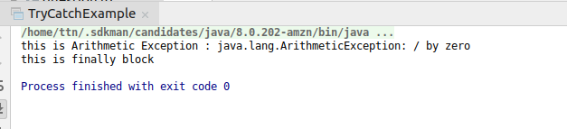

7. WAP to convert seconds into days, hours, minutes and seconds.
package Questions.question7;
public class ConvertSecondsExample {
public void convertSeconds(int seconds) {
int hours = seconds / 3600;
int minutes = seconds % 3600 / 60;
seconds = (seconds % 3600) % 60;
System.out.println("time is :" + hours + "," + minutes + "," + seconds);
}
public static void main(String[] args) {
ConvertSecondsExample convertSecondsExample = new ConvertSecondsExample();
convertSecondsExample.convertSeconds(86399);
}
}
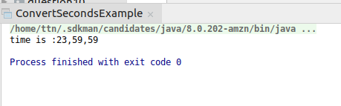

8. WAP to read words from the keyboard until the word done is entered. For each word except done, report whether its first character is equal to its last character. For the required loop, use a
a)while statement
b)do-while statement
package Questions.question8;
import java.util.Scanner;
public class ReadWordsFromWhile {
public static void main(String[] args) {
Scanner sc = new Scanner(System.in);
String string = sc.next();
while (!string.equals("done")) {
if (string.charAt(0) == string.charAt(string.length() - 1)) {
System.out.println("first character and last character is equal " + string);
} else {
System.out.println("first Character and last Character is not equal " + string);
}
string = sc.next();
}
}
}
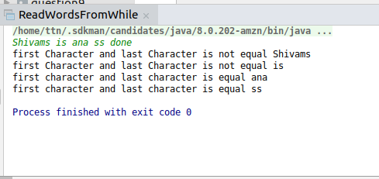

package Questions.question8;
import java.util.Scanner;
public class ReadWordsFromDoWhile {
public static void main(String[] args) {
Scanner sc = new Scanner(System.in);
System.out.println("Enter the String");
String string = sc.next();
if(string.equals("done")){
System.exit(0);
}else{
do {
if (string.charAt(0) == string.charAt(string.length() - 1)) {
System.out.println("first character and last character is equal " + string);
} else {
System.out.println("first Character and last Character is not equal " + string);
}
string=sc.next();
} while(!string.equals("done"));
}
}
}
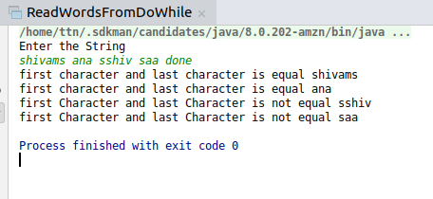

9. Design classes having attributes for furniture where there are wooden chairs and tables, metal chairs and tables. There are stress and fire tests for each products.
package Questions.question9;
abstract class furniture {
private String wchairname;
private String wtablename;
private String mchairname;
private String mtablename;
public void wooden(String chairname,String tablename){
this.wchairname=chairname;
this.wtablename=tablename;
System.out.println("Wooden chair is : "+wchairname+ " Wooden Table is : "+wtablename);
}
public void Metal(String Chairname,String tablename){
this.mchairname=Chairname;
this.mtablename=tablename;
System.out.println("Metal chair is : "+mchairname+ " Metal Table is : "+mtablename);
}
public abstract void stressForWoodenItems(int stress);
public abstract void fireForWoodenItems(int fire);
public abstract void fireForMetalItems(int fire);
public abstract void stressForMetalItems(int stress);
}
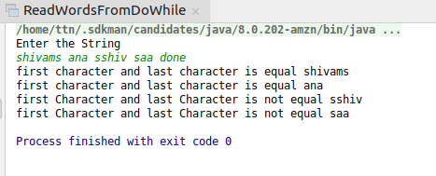

10. Design classes having attributes and method(only skeleton) for a coffee shop. There are three different actors in our scenario and i have listed the different actions they do also below
* Customer
- Pays the cash to the cashier and places his order, get a token number back
- Waits for the intimation that order for his token is ready
- Upon intimation/notification he collects the coffee and enjoys his drink
( Assumption: Customer waits till the coffee is done, he wont timeout and cancel the order. Customer always likes the drink served. Exceptions like he not liking his coffee, he getting wrong coffee are not considered to keep the design simple.)
* Cashier
- Takes an order and payment from the customer
- Upon payment, creates an order and places it into the order queue
- Intimates the customer that he has to wait for his token and gives him his token
( Assumption: Token returned to the customer is the order id. Order queue is unlimited. With a simple modification, we can design for a limited queue size)
* Barista
- Gets the next order from the queue
- Prepares the coffee
- Places the coffee in the completed order queue
- Places a notification that order for token is ready

11. Convert the following code so that it uses nested while statements instead of for statements:
int s = 0;
int t = 1;
for (int i = 0; i < 10; i++)
{
s = s + i;
for (int j = i; j > 0; j−−)
{
t = t * (j - i);
}
s = s * t;
System.out.println("T is " + t);
}
System.out.println("S is " + s);
package Questions.question11;
public class NestedWhileExample {
public static void main(String[] args) {
int s = 0;
int t = 1;
int i=0;
while (i < 10)
{
s = s + i;
int j = i;
while (j > 0)
{
t = t * (j - i);
j--;
}
s = s * t;
System.out.println("T is " + t);
i++;
}
System.out.println("S is " + s);
}
}
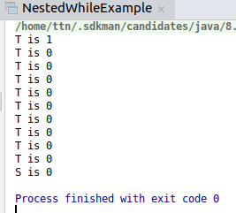

12.What will be the output on new Child(); ?
class Parent extends Grandparent {
{
System.out.println("instance - parent");
}
public Parent() {
System.out.println("constructor - parent");
}
static {
System.out.println("static – parent");
}
}
class Grandparent {
static {
System.out.println("static - grandparent");
}
{
System.out.println("instance - grandparent");
}
public Grandparent() {
System.out.println("constructor – grandparent");
}
}
class Child extends Parent {
public Child() {
System.out.println("constructor - child");
}
static {
System.out.println("static - child");
}
{
System.out.println("instance - child");
}
}
Answer 12:
static - grandparent
static - parent
static -child
instance - grandparent
constructor - grandparent
instance – parent
constructor – parent
instance -child
constructor - child
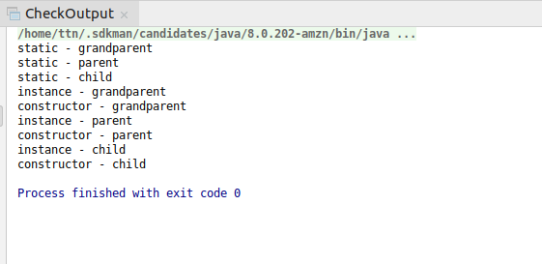

Q13. Create a custom exception that do not have any stack trace.
package Questions.question13;
import java.util.Scanner;
public class CustomException extends Exception{
public CustomException(){
System.out.println("age does not less than 1");
}
@Override
public void printStackTrace() {
}
}
class CheckException{
public static void main(String[] args) {
Scanner sc=new Scanner(System.in);
int age=sc.nextInt();
try {
if (age > 1) {
System.out.println("age is ok");
} else{
throw new CustomException();
}
}catch(CustomException ex){
ex.printStackTrace();
}
}
}
